

**Department of CSE**

**CSE209 Lab**

**Course Name: Electrical Circuits**

**Course Code: CSE209**

**Section No: 2**

**Experiment No: 04**

**Name of the Experiment:** Bias Point Detail Analysis of DC Circuit with dependent Sources Using PSpice Schematics.

**Date of submission: 07/09/21**

Student’s Name: Md Abdul Ahad Rifat

Student’s ID: 2020-1-60-215

**Submitted to**

Rashedul Amin Tuhin

Senior Lecturer

Department of Computer Science and Engineering

East West University

**Objectives:**

1. To analyze Bias Point Detail of DC circuit with dependent source using PSpice Schematics.

**Circuit Diagram(s):**

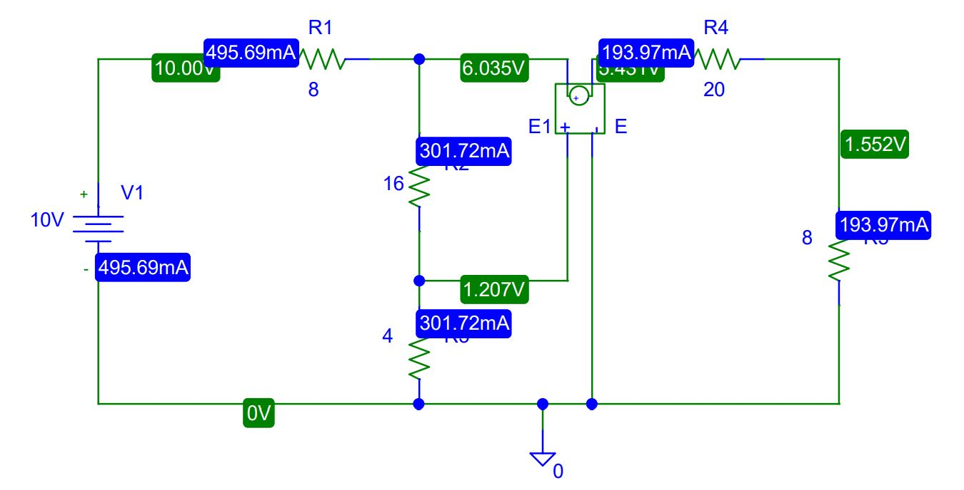

**Figure 1.PSpice Schematic diagram for circuit of VCVS**

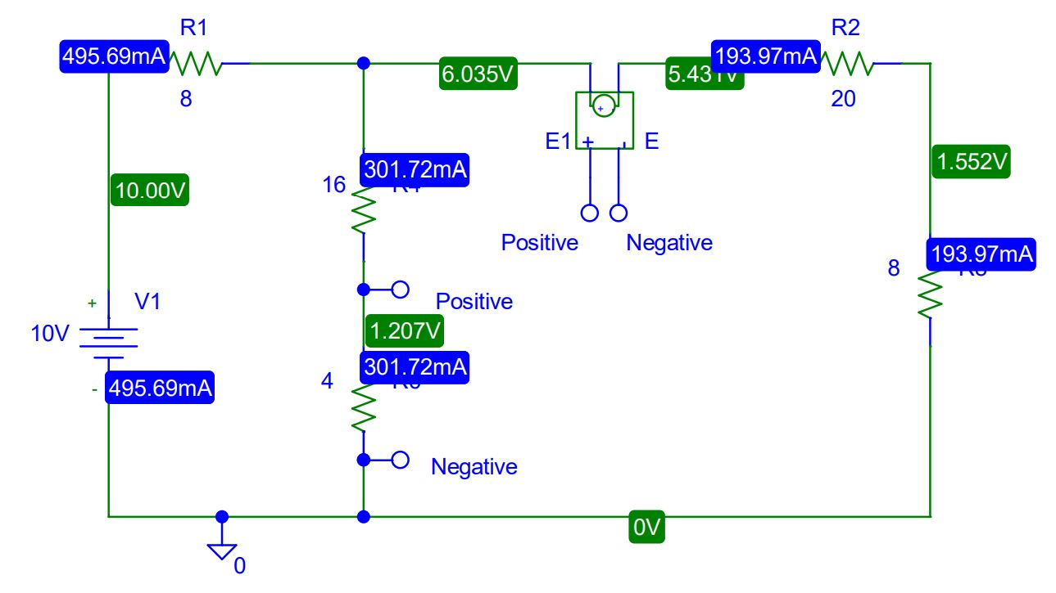

**Figure 2.PSpice Schematic diagram with connection bubbles for circuit of VCVS**

**3**

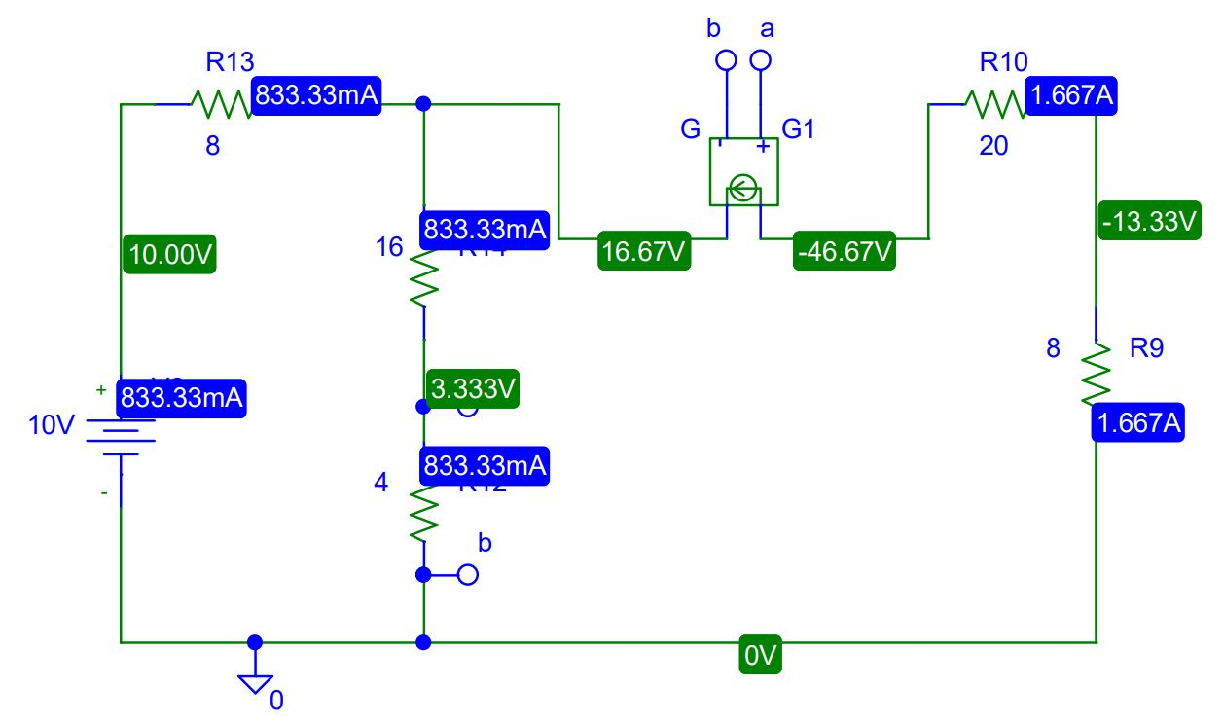

**Figure 3.PSpice Schematic diagram with connection bubbles for circuit of VCCS**

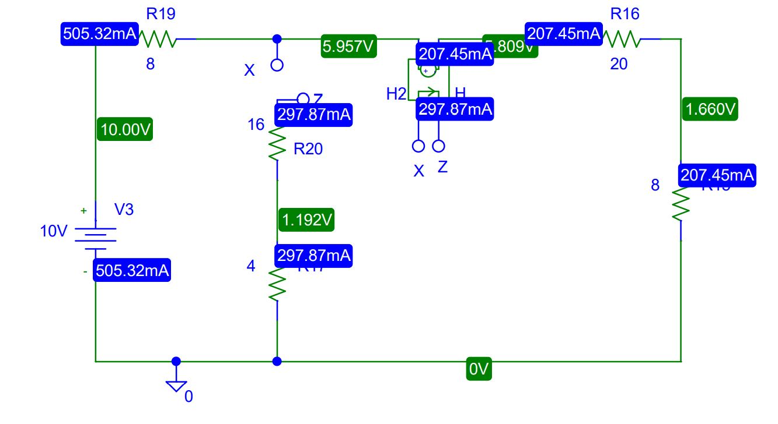

**Figure 4.PSpice Schematic diagram with connection bubbles for circuit of CCVS**

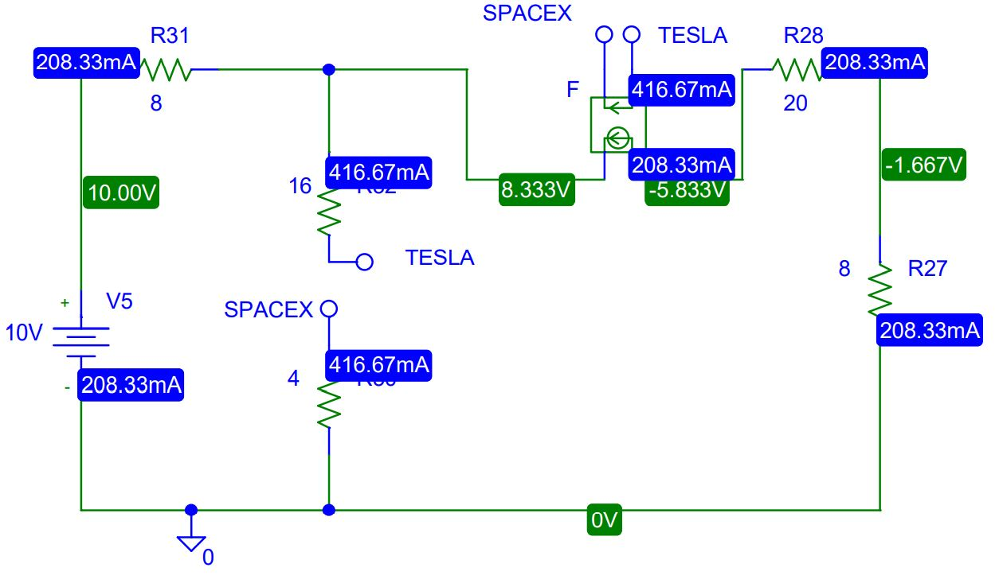

**Figure 5.PSpice Schematic diagram with connection bubbles for circuit of CCCS**

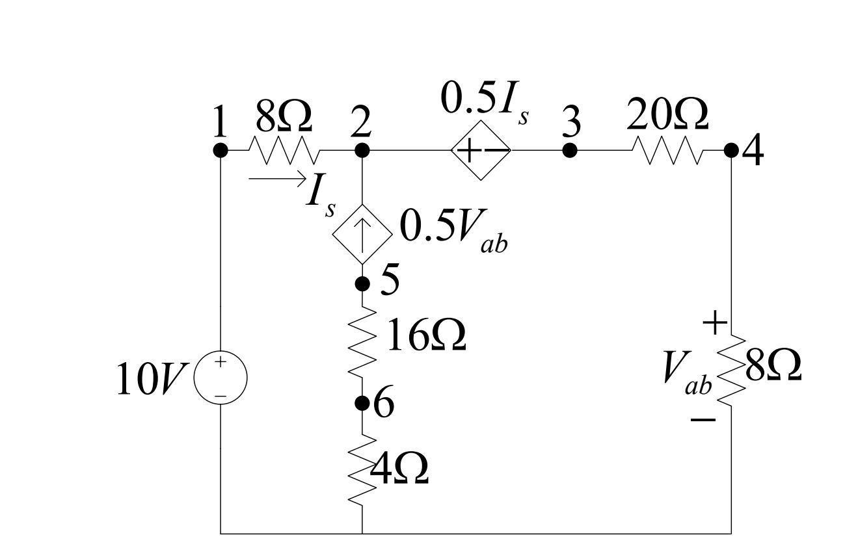

**Figure 6. A circuit with VCCS and CCVS.**

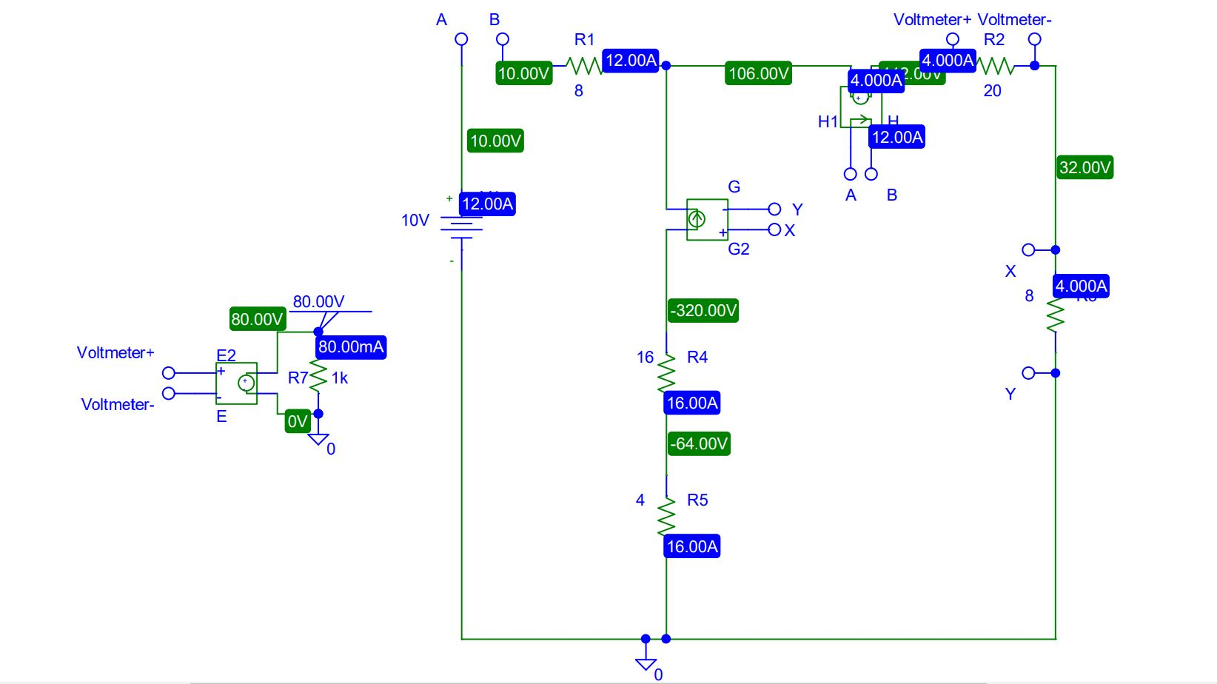

**Figure 7. PSpice Schematic diagram with connection bubbles for circuit of Figure 6 with VCCS and CCVS.**

**Post-Lab Report Questions and Answers:**

1. Theoretically calculate all the currents and the voltages for the circuit shown in Figure 6.

**Answer:**

**Using Mesh Analysis:**

Here, $First Mesh Current I_{s }=i_{1}$

Let $Second Mesh Current i_{2}$

Applying KCL at node 2,

$i_{2}-i_{1}=0.5V_{ab}……………….. (1)$

Applying KVL at Super Mesh 1,

${-8.5i}_{1}+10-{28i}_{2}=0……………….. (2)$

Solving equation 1 and 2 we get,

$$i_{1 }=-12A$$

$$i_{2}=4A$$

$$V_{ab}=(8*4)v=10 v$$

$$V_{12}=\left(8*-12\right)v=-96v$$

$$V_{34}=\left(4*20\right)v=80v$$

$$V_{56}=\{\left(i_{2}-i_{1 }\right)*16\}v=256v$$

$$V_{60}=\{\left(i_{2}-i_{1 }\right)*4\}v=64v$$

1. Compare the theoretical solution of the circuit shown in Figure 6 with the solutions obtained from PSpice.

**Answer:** There has been no change in theoretical calculation value in Figure 6 and Pspice simulation value in Figure 7. But in lab if we calculate the value then we get some discrepancy but in Pspice we get exact same value. In figure 7 I created an external Voltmeter to measure the voltage in node 3, 4 and use bubbles to wireless connection into the circuit and this value also same the theoretical value.

**Conclusion:** In experiment 7 we use DC dependent sources and then we calculate the value of Voltages and currents using PSpice simulation and theoretically. In this experiment, we use VCVS, VCCS, CCCS, CCVS to draw out circuits also use bubbles in our circuit and understood how bubbles work. Actually, the bubble is a wireless connection in the circuit. If we did not use bubbles then our circuit looks clumsy. If we use bubbles to CCCS and CCVS then our circuit must be an open circuit otherwise we will get an error. In the end, this experiment main target is to analyze the Bias Point Detail of the DC circuit with dependent source.